Lesson 06 Demo 05

Configuring Pod Storage Using hostPath-Based PV
and PVC

Objective: To configure pod storage using hostPath-based PersistentVolume (PV) and PersistentVolumeClaim (PVC) in Kubernetes for efficient data storage and retrieval

Tools required: kubeadm, kubectl, kubelet, and containerd

Prerequisites: A Kubernetes cluster should already be set up (refer to the steps provided in Lesson 01, Demo 01 for guidance).

Steps to be followed:
- Create PersistentVolume
- Create PersistentVolumeClaim
- Deploy a pod in a new namespace
- Validate the pod
- Verify data persistence

Step 1: Create PersistentVolume

- Create the YAML file using the command below:
nano pv.yaml
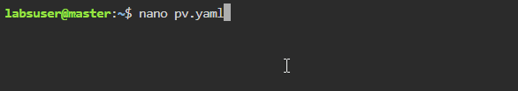

- Add the following code to the pv.yaml file to create the pod:
apiVersion: v1
kind: PersistentVolume
metadata:
name: task-pv-volume
labels:
type: local
spec:
storageClassName: manual
capacity:
storage: 10Gi
accessModes:
- ReadWriteOnce
hostPath:
path: "/mnt/data"
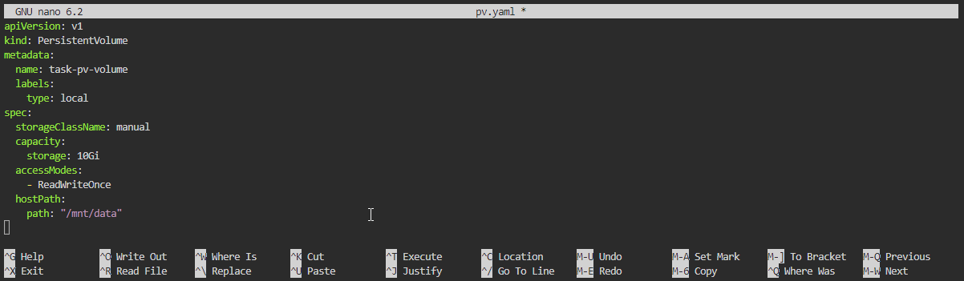

- Use the below command to validate the content of the pv.yaml file:
cat pv.yaml
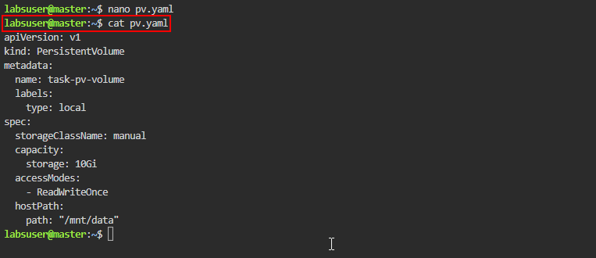
- Run the below command to apply the Kubernetes resource configuration from the YAML file:
kubectl apply -f pv.yaml
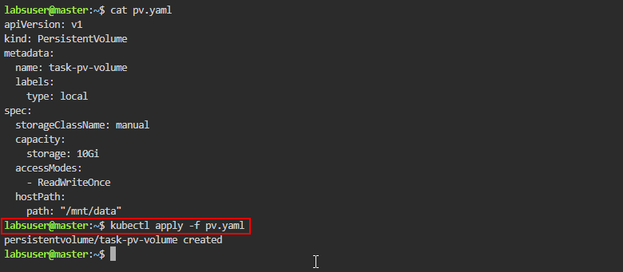
- List all the PVs in the Kubernetes cluster using the following command:
kubectl get pv
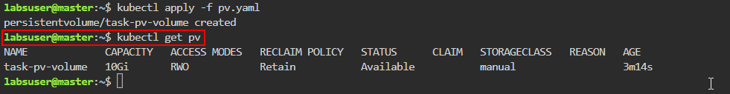

Step 2: Create PersistentVolumeClaim

- Create the YAML file using the following command:
nano pvc.yaml
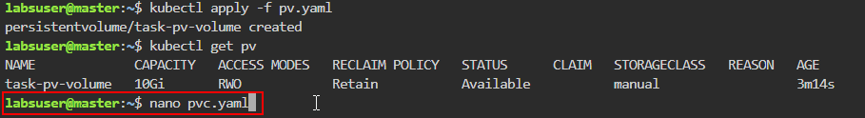
- Add the following code to the pvc.yaml file:
apiVersion: v1
kind: PersistentVolumeClaim
metadata:
name: task-pv-claim
spec:
storageClassName: manual
accessModes:
- ReadWriteOnce
resources:
requests:
storage: 3Gi
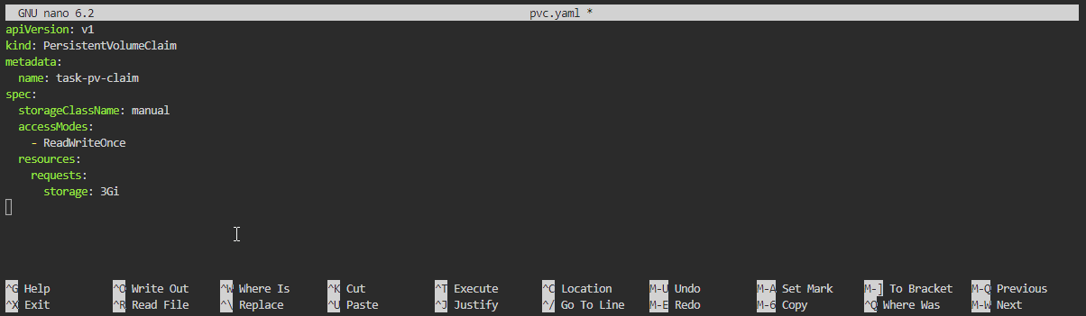
- Use the cat command to validate the content of the pvc.yaml file
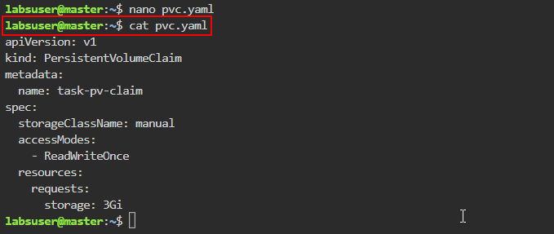
- Apply the Kubernetes resource configuration defined in the pvc.yaml file to create the PVC using the following command:
kubectl apply -f pvc.yaml
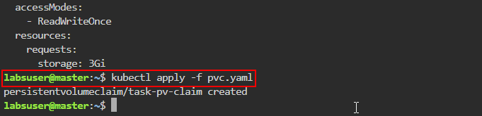

- List all the PVs in the Kubernetes cluster using the following command:
kubectl get pv
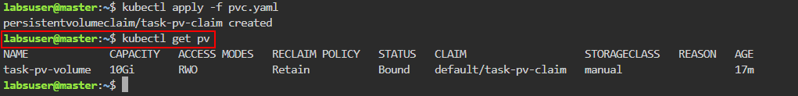

- List all the PVCs in the Kubernetes cluster using the following command:
kubectl get pvc
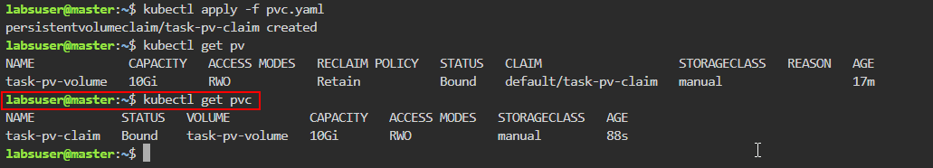

Step 3: Deploy a pod in a new namespace

- Create the YAML file using the following command:
nano pod-pvc.yaml
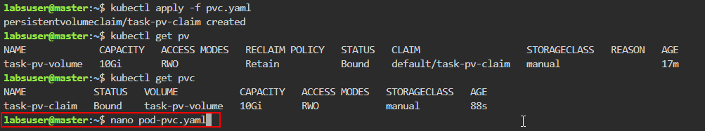
- Add the following code to the pod-pvc.yaml file:
apiVersion: v1
kind: Pod
metadata:
name: task-pv-pod
spec:
volumes:
- name: task-pv-storage
persistentVolumeClaim:
claimName: task-pv-claim

containers:
- name: task-pv-container
image: nginx
ports:
- containerPort: 80
name: "http-server"
volumeMounts:
- mountPath: "/usr/share/nginx/html"
name: task-pv-storage
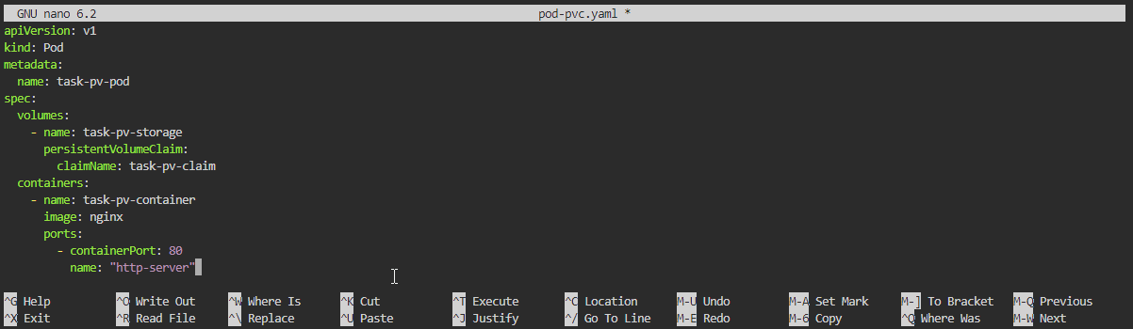

- Use the cat command to validate the content of the pod-pvc.yaml file
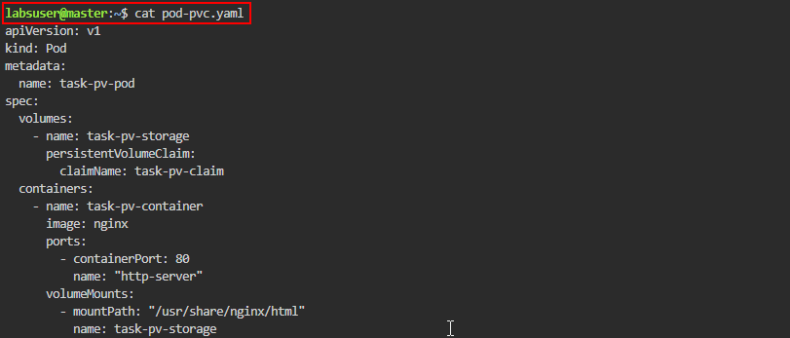
- Apply the Kubernetes pod with the configuration defined in the pod-pvc.yaml file using the following command:
kubectl apply -f pod-pvc.yaml
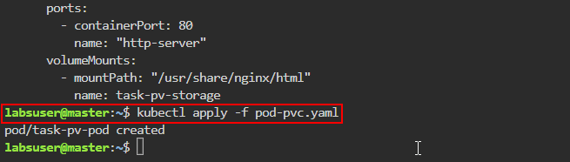
- List all the PVCs in the Kubernetes cluster using the following command:
kubectl get pvc
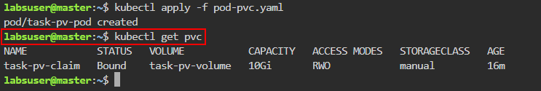

Step 4: Validate the pod

- Create an empty index.html file in the /usr/share/nginx/html directory within the task-pv-pod using the following command:
kubectl exec -it task-pv-pod -- touch /usr/share/nginx/html/index.html
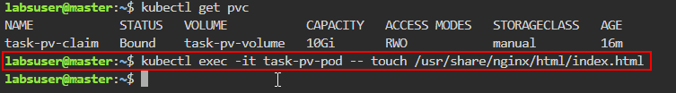
- List the content of the /usr/share/nginx/html/ directory within the task-pv-pod using the following command:
kubectl exec -it task-pv-pod -- ls /usr/share/nginx/html/
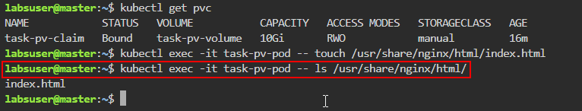
- Retrieve the status and details about the task-pv-pod using the following command:
kubectl get pod task-pv-pod -o wide
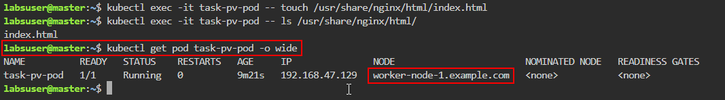
- List the contents of the /mnt/data directory within the task-pv-pod by running the following command:
ls /mnt/data
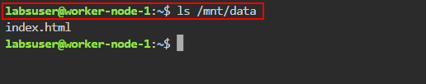
Note: Execute the above command in the worker-node-1

Step 5: Verify data persistence

- On the master node, delete the Kubernetes pod created from the configuration defined in the pod-pvc.yaml file using the following command:
kubectl delete -f pod-pvc.yaml
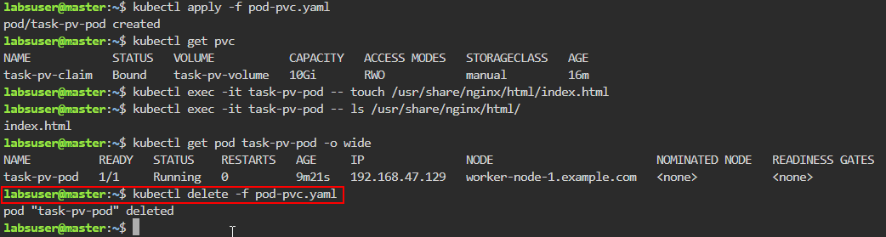
- On the worker-node-1, list the contents of the /mnt/data directory within the task-pv-pod by running the following command:
ls /mnt/data
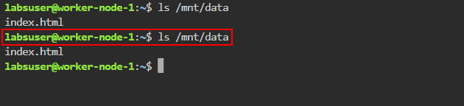
- Deploy the Kubernetes pod with the configuration defined in the pod-pvc.yaml file using the following command:
k apply -f pod-pvc.yaml
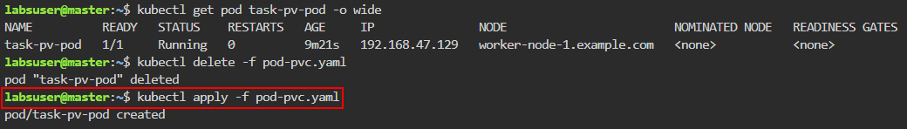

- List the content of the /usr/share/nginx/html/ directory within the task-pv-pod using the following command:
k exec -it task-pv-pod -- ls /usr/share/nginx/html/
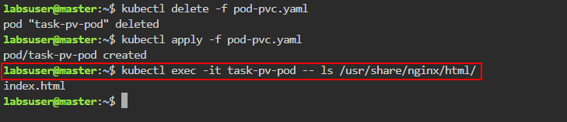
By following these steps, you have successfully configured a Kubernetes pod for data storage and retrieval using hostPath-based PV and PVC.

